Assignment 4

Chaiwat Plongkaew 2021326660023

telnet mail.hust.edu.cn 25

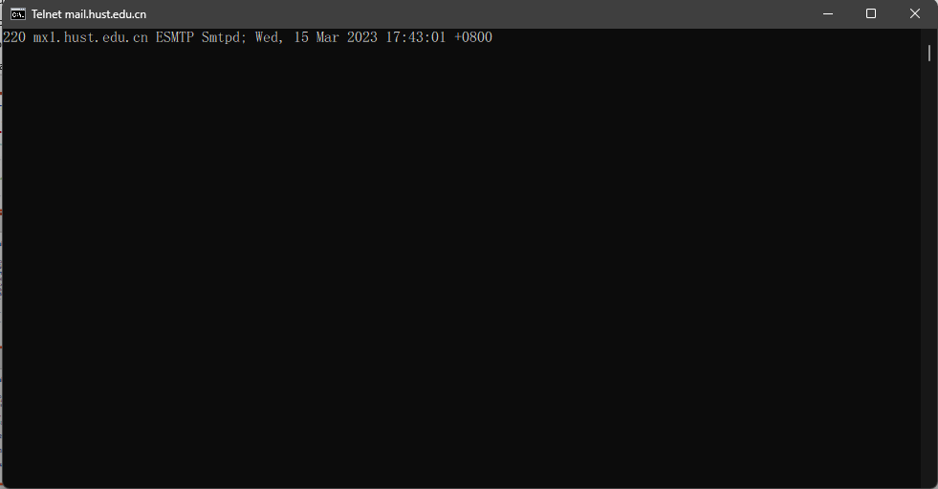

telnet cs.hust.edu.cn 80

